You have to deliver not only the code, but also the corresponding screenshoots (you can make a word document) with the different tests:

# - Create a publication

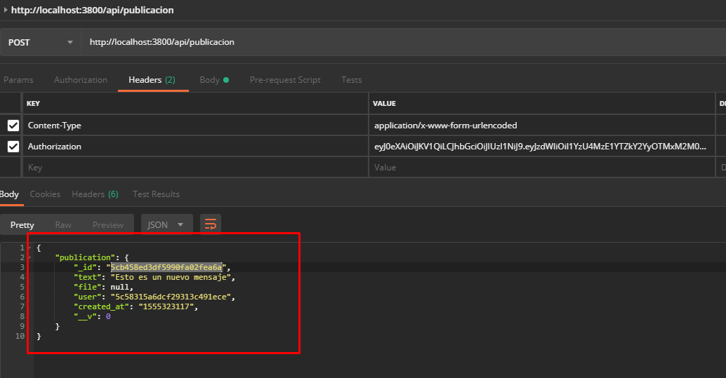

U have to text something, to do that, u have to go to “Body” section and créate and complete the “Text” Field:

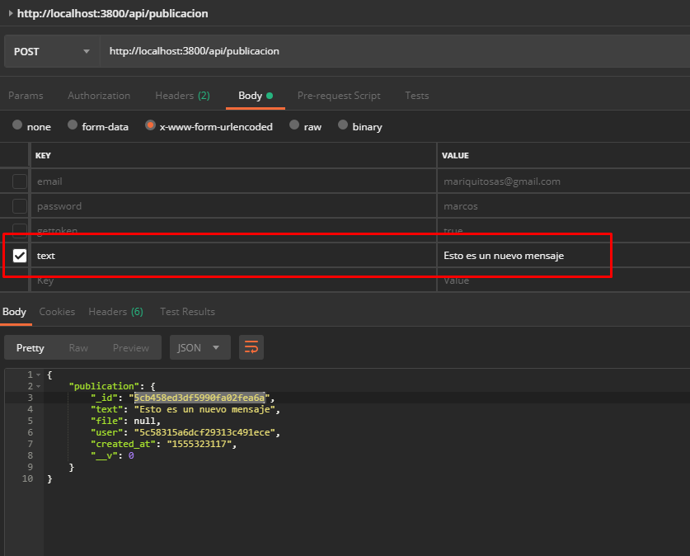

# - List publications

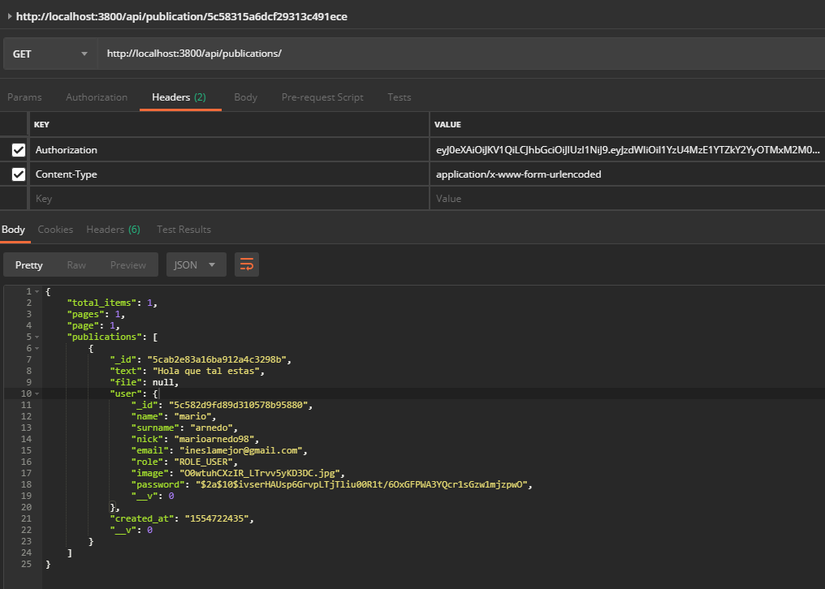

In this page shows to us the text that the user that u follow write

# - Get a publication

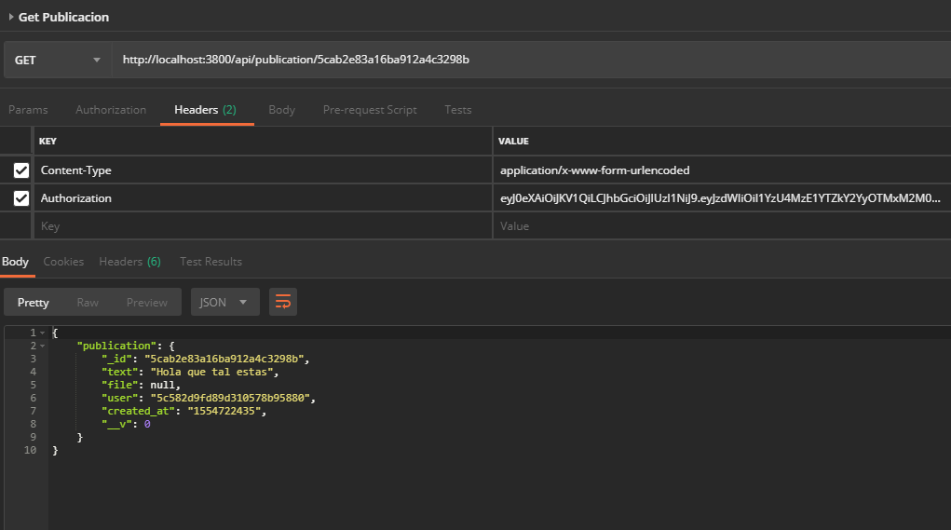

# - Delete a publication

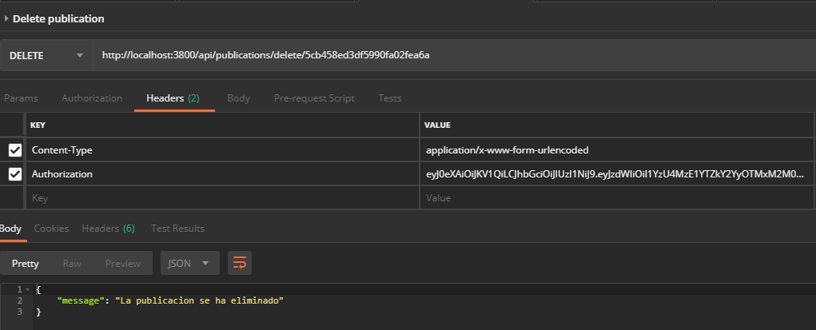

# - Upload a file

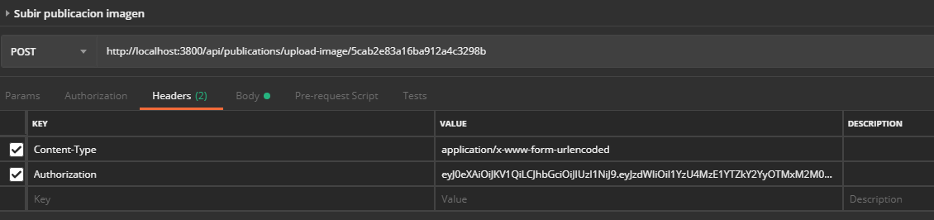

U have to pass the image, to do that, u have to go to the “Body” section and créate a new field call image, select type file and select the image

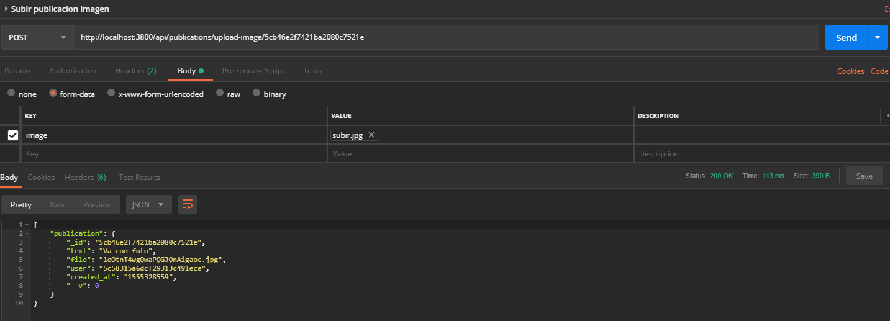

# - Counters

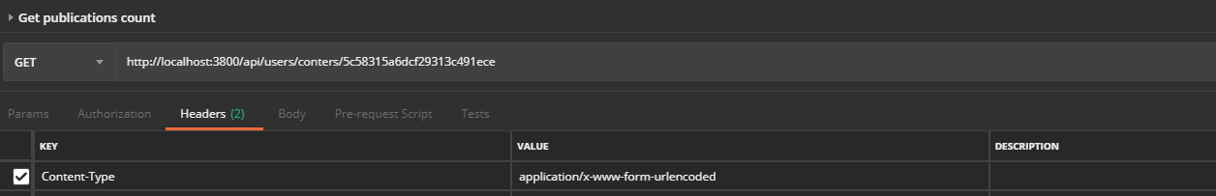  
To do this, u dont have to pass any token